Ihr Ansprechpartner:
Dirk Rott, Leiter Marketing

01 September 2022

Press Release WA22M3: World's most compact Ethernet/IP encoder

Images and text material are released for publication in the trade press (print and online).
Please send us a specimen copy after publication. Thank you very much for your efforts.
________________________________________________________________________
World's most compact Ethernet/IP encoder
Universal Industrial Ethernet encoder with PROFINET, EtherCAT and EtherNet/IP
Wachendorff is expanding its range of Ethernet-based encoders: Encoders with the EtherNet/IP protocol are now available, including the most compact in the world: the WDGA58F. Wachendorff's R&D team has succeeded in minimising the sensor to an installation depth of just 46.5 mm.
The encoders are certified by the ODVA. The resolution in single and multi-turn can be individually configured via an integrated web server (single-turn 16 bit, multi-turn 43 bit).
The very high environmental data, e.g. temperature range from -40 °C up to +85 °C, shock 1,000 m/s² or vibration 50 m/s² at 10-2000 Hz, allow the use in harsh industrial environments as well as in mobile working machines.
The devices with hollow end shafts eliminate the need for additional couplings and the devices with shafts guarantee a long-lasting and stable connection with their very high bearing loads of up to 400 N.
More information about the EtherNet/IP encoders from Wachendorff:
https://www.wachendorff-automation.com/encoder-absolute-magnetic-ethernet-ip/
In the Universal Industrial Ethernet version, it is possible to switch between Ethernet/IP, EtherCat and PROFINET. This noticeably reduces storage costs and increases flexibility.
More information about the absolute Universal Industrial Ethernet encoder WDGA U-IE:
https://www.wachendorff-automation.com/universal-industrial-ethernet-en/
Images (Wachendorff Automation):

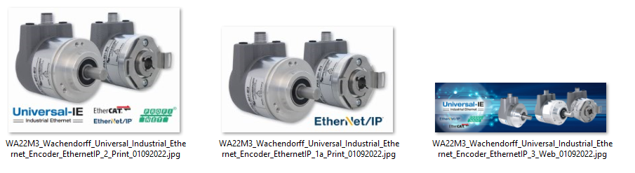

Wachendorff Automation GmbH & Co. KG

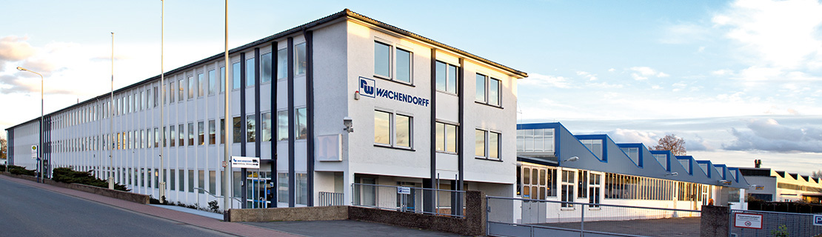

Wachendorff Automation (Geisenheim/Germany) stands for the development and manufacture of innovative encoders, motor feedback and complete measuring systems for use in a wide variety of series applications in mechanical and plant engineering, renewable energies and mobile machines.
The focus is on an extensive standard program with numerous options as well as the efficient development of customer-specific solutions. More than 3,000 customer solutions are already in series production worldwide.
The optimum combination of electronics, optics and mechanics make Wachendorff encoders the most robust, reliable and innovative devices on the market.
High protection classes, wide temperature ranges and the very robust electronics enable use also in very demanding applications. Unique worldwide: 5-year warranty!
Wachendorff has sales offices in the USA and China as well as a worldwide network of competent distributors.
More details:
www.wachendorff-automation.com

Additional press material:
https://www.wachendorff-automation.com/latest-information/

