Your contact person
Dirk Rott, Head of Marketing

August 8th, 2019/DRO

Press release WA1906: New Silent Move Compact digital shaft copying system

Images and text material are released for publication in the trade press (print and online).
Please send us a specimen copy after publication. Thank you very much for your efforts.

interlift 2019, Augsburg, hall 1, both 1101

Position and speed measurement of elevators / lifts
Reliable and precise measurement with Silent Move Compact
New: Silent Move Compact
Experience shows in detail

For more than 25 years, Wachendorff Automation has been developing and manufacturing systems and encoders for worldwide use in a wide variety of applications in the fields of mechanical and plant engineering, elevator construction, mobile machinery and renewable energies. More than 2,500 implemented variants demonstrate the great flexibility and absolute customer orientation of Wachendorff. Due to the highest mechanical and electrical stability of the Wachendorff encoders and systems, the company guarantees a 5-year warranty - this is unique worldwide.

New: Silent Move Compact
In addition to incremental and absolute encoders, Wachendorff also supplies specially developed digital shaft positioning systems for the elevator / lift industry.
Now Wachendorff has succeeded in further compressing the electronics and mechanics of the Silent Move toothed belt system and reducing them to the essentials. The result is the Silent Move Compact system.
The intelligent design with encoder, pre-assembled toothed pulley and idler pulley as well as the optimally dimensioned vibration dampers ensure maximum operational reliability and easy installation. The very smooth running special toothed belt is securely guided out of the toothed pulley and tensioning roller. The open design minimizes the work steps of the assembly and simplifies the safe insertion of the toothed belt.

Experience shows in the details ... Save time and space with the system
While designing the Silent Move Compact shaft copying system, Wachendorff was fully geared to the needs of elevator manufacturers and service companies: Reduced to the essentials to save costs and installation space without losing sight of reliability, accuracy and robustness. Due to the open system and the mounting bracket with its four slotted holes, an optimal attachment to the elevator car is easyly possible. The pre-assembled tensioning roller prevents adjustment during operation and eliminates the need to adjust the tensioning roller during installation because the correct tension of the toothed belt is ensured by the supplied spring.

- Guided belt measuring systen
- Very compact design
- Absolute position of the elevator car
- Optimized silencing
- Can be combined with many standard encoders of the series WDGA 58B (absolute)
or WDGI 58B (incremental)

More information: www.wachendorff-automation.com/digital-shaft-copying/

Images (Wachendorff Automation):
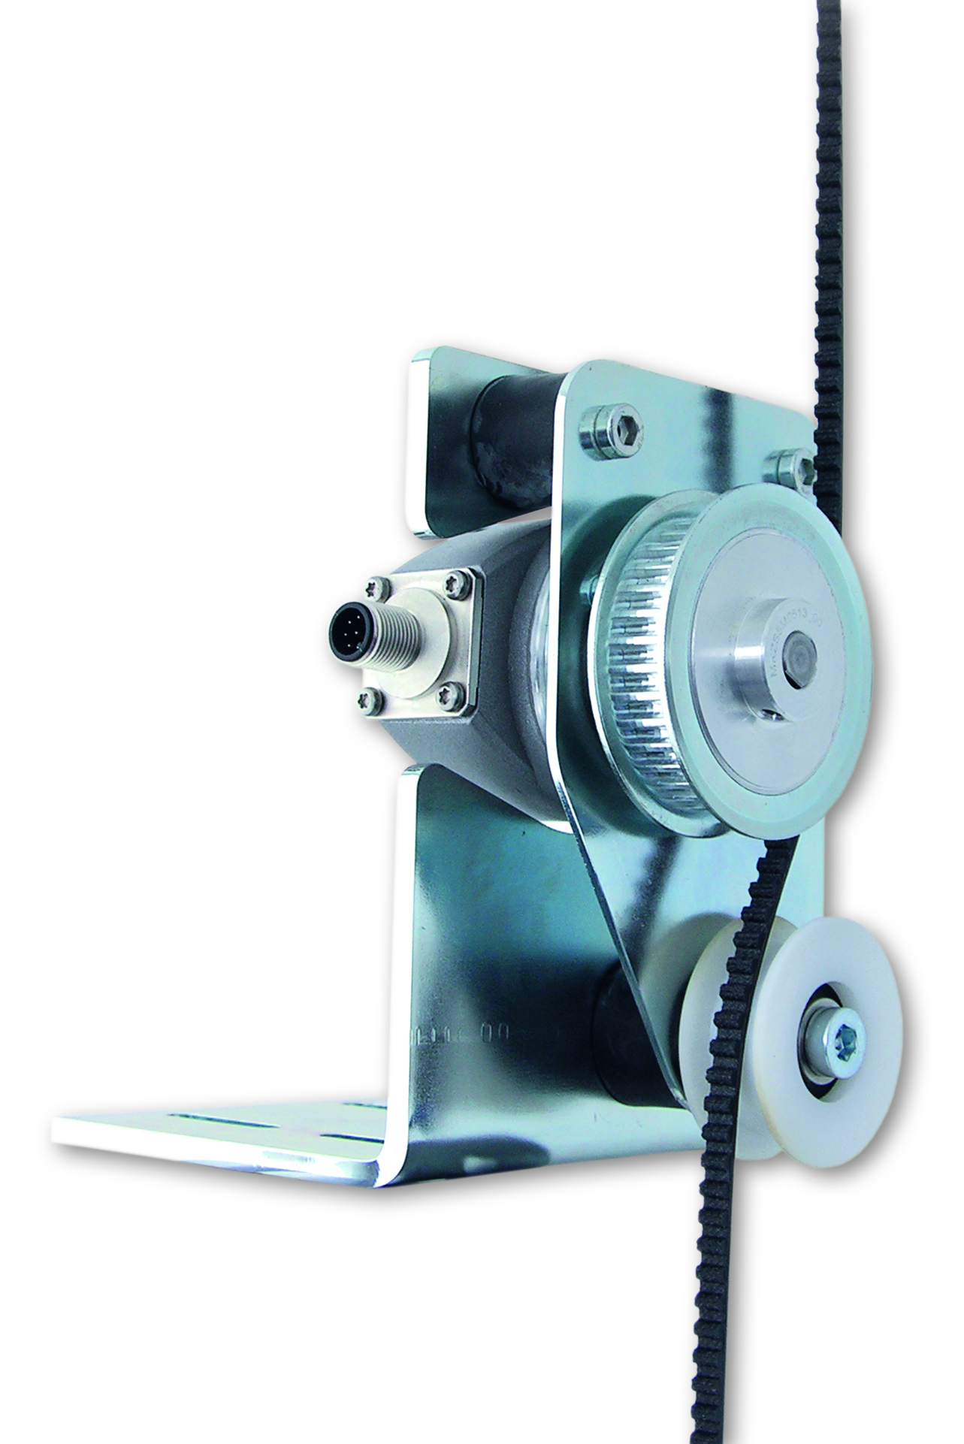 WA1906_Wachendorff_Silent_Move_Compact_01.jpg

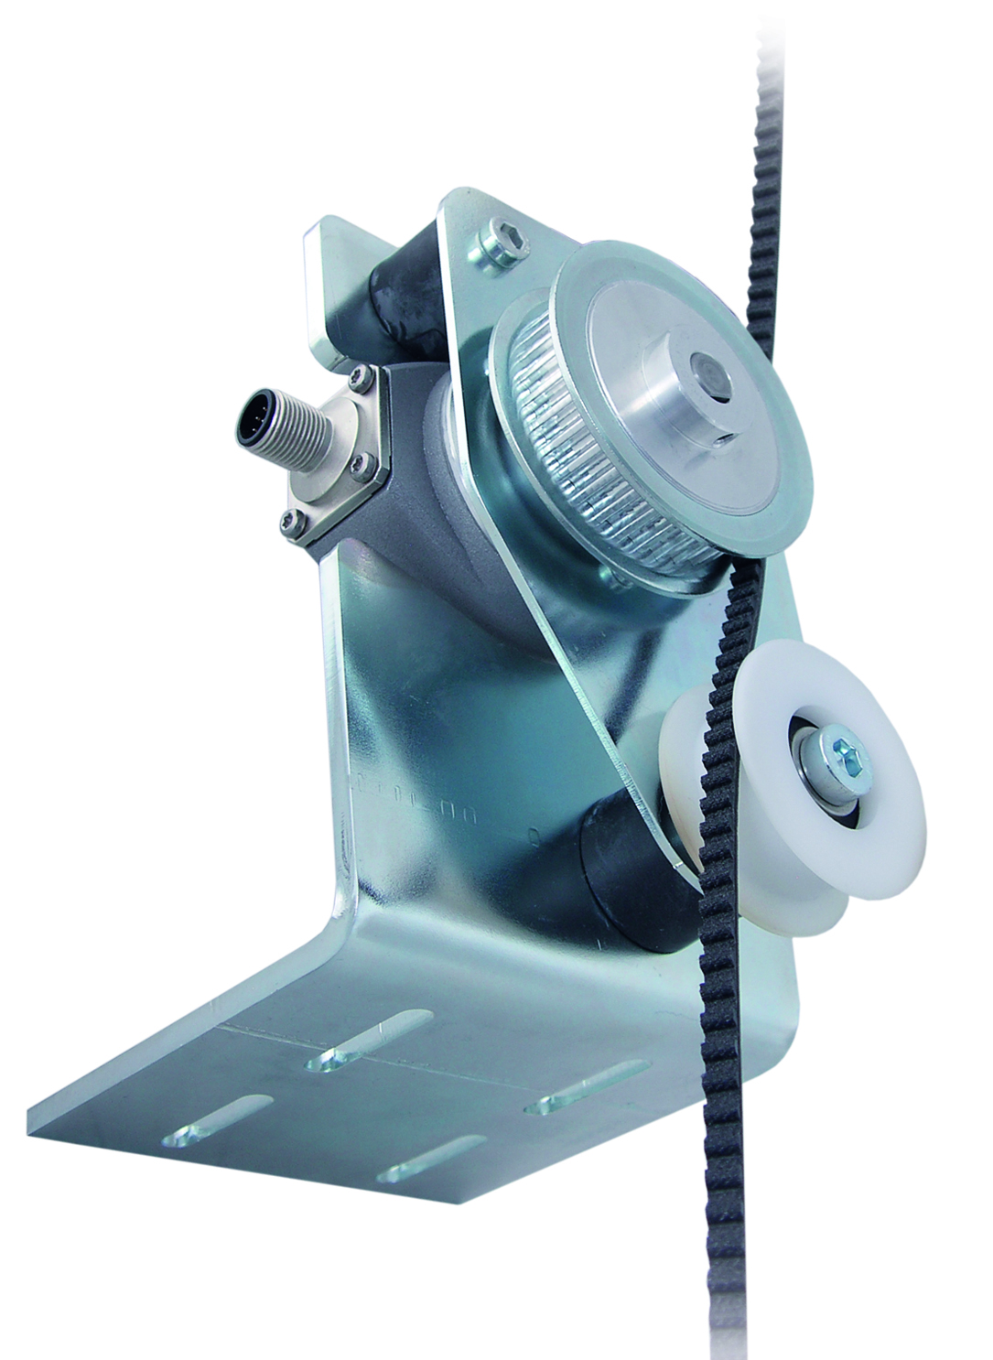 WA1906_Wachendorff_Silent_Move_Compact_02.jpg

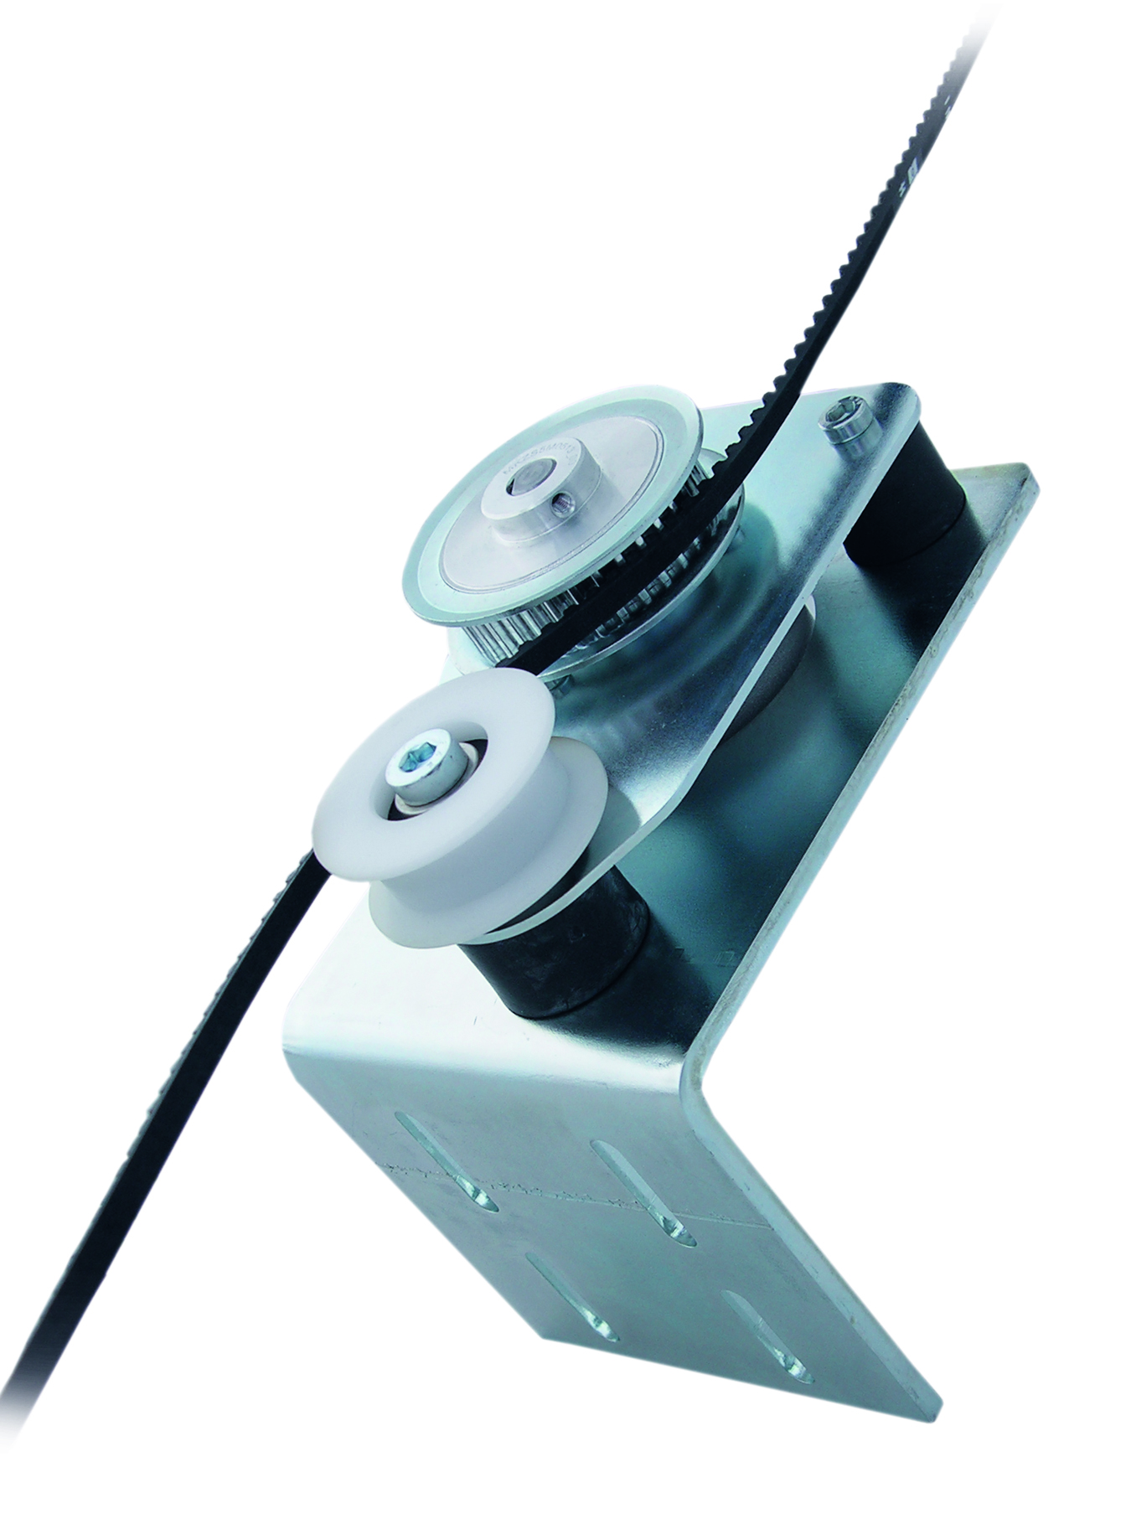 WA1906_Wachendorff_Silent_Move_Compact_03.jpg

