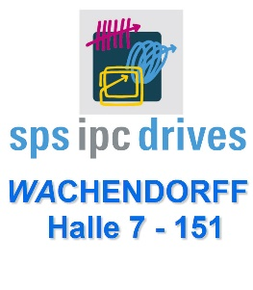
Editorial contact partner:
Dirk Rott, Head of Marketing

10 November 2017/DRO
Press release WA1704: Motor Feedback from the New Generation
The images/text material are approved for publication in the trade press (print and online). Please send us a voucher copy after publication. Thank you in advance for your efforts.
________________________________________________________________________
Authors:
Robert Wachendorff
Dieter Schömel (product manager)
Wachendorff Automation GmbH & Co. KG

Applications:
- Step motors
- Servo motors
- Step-servo motors
- Pulley systems
- CAM switches

Motor Feedback of the Latest Generation for Position Measuring
Wachendorff Automation has been developing and producing encoders and systems for worldwide use in a wide range of applications for more than 25 years. Wachendorff always places great value on sturdiness, durability and the use of the latest technologies. These were exactly the determining parameters when developing the absolute encoder series WDGA almost 10 years ago.
To meet these requirements, Wachendorff only considered a magnetic solution, both to determine the number of steps (single turn) as well as for the revolution counter (multi-turn).
Compared to optical encoders with a gearing unit, the magnetic encoders of the WDGA series are much more sensitive to shocks or vibrations, which can occur constantly when used in machines.
Despite the compact design, the performance of the WDGA encoders is many times higher than the performance of optical systems in gear technology.
The technologies QuattroMag® for single turn and EnDra® for multi-turn, which are patented by Wachendorff, deliver several millions of revolutions without overrun at a maximum single turn resolution of up to 16 bits and a measurement accuracy of +/- 0.09 °, paired with an excellent dynamics of 50 µsec.

QuattroMag® is based on 4 hall sensors in conjunction with a patented calculation algorithm that calculates the magnetic field generated by a diametrically arranged magnet so that any interference of the hall signals cancels each other out. This also allows Wachendorff to use the magnetic single-turn technology in highly accurate and dynamic applications.
The multi-turn technology EnDra® uses the energy generated by the magnetic field in an energy wire made of a magnetically soft core and a magnetically hard shell. The rotation of the shaft with the magnet builds up energy that generates an energy pulse for each north-south transition regardless of the speed, which can be used to supply a meter and memory. Additional electronic components ensure the detection of the direction of rotation.
This results in the highlight of the EnDra® technology, namely doing without the use of a backup battery to maintain the values in the encoder memory in the event of a loss of power.
Without a battery, the WDGA absolute encoder is always able to measure the correct position and store it in the internal memory, even in a de-energised state. Once power returns, the encoder then transmits the position readings to the control system.
WDGA series absolute encoders from Wachendorff are used around the world, for example in wind turbines, mobile work machines, medical equipment, cranes, packaging and filling machines and even in aircraft.
In particular, motors in production machines, mobile work machines or shelving systems, in medical technology or in production robots, for example, require a feedback signal, such as from an encoder, to be able to position quickly and precisely.
In larger motors, the encoder can be installed as a complete closed module on the outside of the motors.
The magnetic technology from Wachendorff now makes it possible to also equip smaller step or servo motors with an absolute encoder system. This is made possible by the compact design of the electronics of the WDGA absolute encoder.
This idea resulted in an absolute encoder kit, which can be integrated in very compact motors.
The Wachendorff kit offers clear advantages compared to resolvers, magnetic sensors with backup batteries and encoder kits with optical scans and gearboxes.
Due to the higher level of robustness against vibrations and other environmental stresses as well as the faster assembly, the company Wachendorff is expecting another step of creative destruction, which they already predicted ten years ago with the introduction of the EnDra® technology.
“Our customers are faced with the task of designing their motors to be increasingly powerful and more compact. With our kit, which consists only of a small PCB with a diameter of just 34 mm and a magnetic that is attached to the front of a shaft, the motor manufacturer gains more space for enhanced performance”, explains Robert Wachendorff, and adds: “With our many years of knowledge, we help our customers with the integration in their motors”.
Wachendorff offers two different concepts for this purpose:
- An operational absolute encoder
- Installation kit

An operational absolute encoder

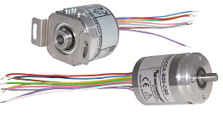
Image (Wachendorff): WA1704_Wachendorff_installation_solution_open_cable_heads.jpg

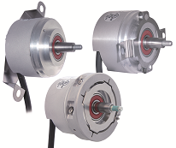
Image (Wachendorff): WA1704_Wachendorff_Motor_feedback_WDGF_versions.jpg
The operational, very compact WDGA absolute encoders have a housing with a diameter of just 36 mm and a depth of just 31 mm. They have their own bearings and can be directly integrated as shaft or hollow shaft encoders. A cable can easily be connected to the motor housing plug. “Some of our customers initially choose this solution, which is ideal for smaller quantities or for the start of a series. The optimisation of space and costs still plays a lesser role here compared to the effort in the development and assembly. “It is an ideal way to manage small quantities and to realise prototypes”, remarks Dieter Schömel, product manager at Wachendorff Automation.

Installation Kit
(consisting of PCB and magnet)
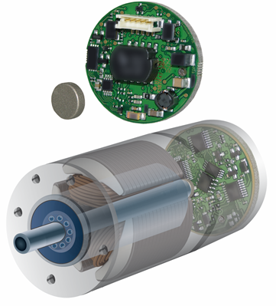
Image (Wachendorff): WA1704_Wachendorff_Motor_feedback_installation_kit.jpg
“For larger series, our customers choose the installation kit solution and we help them with the integration during development and with the setup of the necessary assembly and calibration unit”, explains Robert Wachendorff.
Wachendorff provides the motor manufacturer's developers with the necessary STEP files to adapt the flange and shaft of their motor to the installation set. Based on their many years of experience with this system, Wachendorff offers the normally already experienced motor manufacturers assistance in choosing the right materials and the right geometry for the shielding of the magnetic sensor.
With a normally accurate mounting of the magnet and the PCB, a resolution of about 10 to 12 bits can be achieved without carrying out a calibration. To achieve a resolution of about 16 bits, however, the motor manufacturer requires a sensor calibration with regard to the position and property of the mounted magnet. Wachendorff offers a very pragmatic solution for smaller quantities and in a ramp-up phase of larger series: The motor manufacturer sends its finish-mounted motors to Wachendorff and Wachendorff assembles the installation set, carries out the final test and calibration, seals the motor and then sends it back.
The assembly according to the Lean-Q concept developed by Wachendorff (with a very high level of flexibility and seamless traceability) has corresponding recordings and also offers the customer additional services, such as test logs or customer-specific test sequences.
Only a few additions are added to the motor manufacturer's existing test equipment to set up a final test and calibration unit. The installation set is fully tested and calibrated with an approach up to 256 measurement points and the run-up and continuous operation of the motor in a test cycle of about 3 to 4 minutes.
Wachendorff offers SSI and all versions of CAN as possible interfaces.
“With our installation kits, we make it possible for our customers to enter into completely new applications and to offer their customers more effective functions. We are currently working on making the technologies even more compact to be able to equip even smaller motors with our installation kit. For example, 24 mm is already possible without its own power supply and 18 mm will even be possible in the near future”, says Robert Wachendorff.

More information:
www.wachendorff-automation.com

